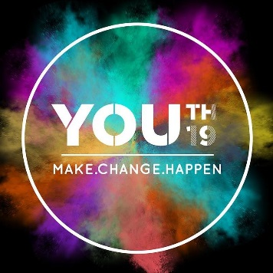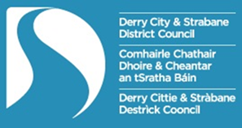

Youth Arts Festival

Derry City & Strabane District Council
Programming Support Fund

Application Form

Please see Guidance Notes for information on completing this form.
Deadline for applications is Friday 15th March by 5pm.
Please return applications by email: youth19artsfestival@derrystrabane.com

Name of Individual/ Organisation

If you are an individual applicant please indicate your age category | 12-17yrs 18-24yrs 24+ yrs
Contact Name
Type of Organisation

Contact Number
Contact Email
Title of Project / Event

Location of Event. Please include postcode(s)

Website / Facebook etc.

Please complete the following section giving as much detail as possible about your planned project / event.

- Event/ Activity Description:

Please include detail on your idea, what you want to do and how you plan to do it:
- who will be involved
- who is your target participant/ audience
- what you want to do
- why you want to do it
- where activity will take place
- how you will deliver your proposal
- when your activity will happen
(35 marks)

(600 words max)

Please note: Please indicate if you would like support sourcing a venue/ partner for your event, giving an indication of requirements.

Please outline how the event will benefit young people aged 12-24 in the Derry City and Strabane District area and how it links to one or more of the key themes of Youth 19:
- Promote positive health and wellbeing
- Actively promote the meaningful engagement and participation of young people
- Develop skills and provide clear career pathways
(20 marks)

(300 words max)

Please give detail of how young people are involved in the development and delivery of this proposal.

(15 marks)

(300 words max)

Please outline previous experience of delivery of similar projects. If you do not have previous experience, please detail how you have thought about delivery and any support you think might help you to deliver your ideas

(10 marks)

(300 words max)

Please outline how you will promote your event, attracting audiences/ participants.

(10 marks)

(100 words max)

Please detail how your proposal will be accessible to people with a disability.

(10 marks)

(100 words max)

Additional Information

Budget

How will the costs of your event be broken down? Your answer should provide a detailed breakdown of exactly where the funding will be used. The following table may be used to assist you.

What you plan to do? | How much it will cost? | How much you need from us? | Other sources of Income
Total Costs

If the cost of the Event is more than you have applied for, have you identified the rest of the funding you need? | Yes No
If yes to the above please indicate:
- Amount Secured
- Amount Pending

Who will benefit?

Please outline your projected participant number

Please outline anticipated audience numbers for your event/activity
Application Authorisation:
Signature: | Date:

