CHILD FRIENDLY COMMUNITY, DERRY & STRABANE:
CHILD & YOUTH ADVISORY BOARD WORKSHOPS

Informed Consent

What is the Child Friendly Cities and Communities Programme?
Unicef are working together with cities and communities across the UK to help make them places where all children and young people feel safe, heard, nurtured and cared for.
We support the people who work with and for children and young people to understand children’s rights and to make sure that they are experienced by every child and young person.
What does this mean for Derry & Strabane?
People working and living across Derry and Strabane are working in partnership with Unicef to become recognised as a Child Friendly Community. At the centre of this lies a commitment to listening to children and young people’s views, considering your opinions and experiences and making sure you have a voice in the design and delivery of services in your city.
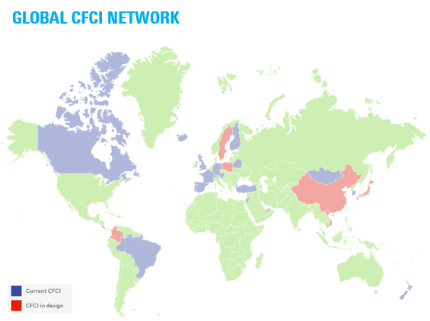
This work is part of Unicef’s global Child Friendly Cities and Communities Initiative, which helps cities and communities in more than 20 countries around the world to put children’s rights and wellbeing at their heart.

The Unicef Child Friendly Cities Initiative is active in over 24 countries across the world!

How will you be involved?
- Meeting up as a CYPAB group from time to time
- Checking adults are fulfilling their promises and listening to children
- Taking part in other workshops on things like children’s rights and design
- Building new skills
- Helping to plan events
- Meeting different people across your community
- Being creative and sharing ideas
- Speaking up for those whose voices are not being heard
- Working well in a team
What if you change your mind about taking part?
We understand you might change your mind! We hope that you will have a great time and want to be a member of the CYPAB group. But if, for any reason things change, no problem. Just let Claire (below) know as soon as possible or on the day. You don’t have to give a reason if you change your mind.
Who’s going to be at the workshop and CYPAB meetings?
- You and other children & young people from across your community
- People who work for the council
- Supporting adults
- Unicef UK staff (Jeni)
Your data
On your consent form, we will make a note of your full name, your gender, your age and the name of your school or youth group (remember that sometimes, knowing your youth group might mean that we know something private about your life, like being a young carer or growing up in care).
This is so that we know who we are reaching and who is participating in the youth governance of the programme. If you want us to delete this information at any time, for any reason, just let Claire know. We will look after your data and won’t share it with anyone else.
To learn more about the work going on between Derry & Strabane and Unicef UK or to ask any questions about the programme, please contact:
Claire Lynch, Children and Young People’s Coordinator
02871 253 253 / youth@derrystrabane.com
THANKS

